Globus Toolkit Use Case:
A Monitoring System for the Earth System Grid

Table of Contents
1 Introduction 2
2 Description/Scenario 2
3 Monitoring System Architecture 2
4 Implementation Details 4
4.1 Required Software 5
4.2 ESG Implementation 5
4.3 Intended Future Implementation 5
5 Postconditions 6
5.1 ESG Visualizer 7
5.2 Details Visualizer 7
5.3 Archiver Visualizer 8
6 Resources 8

Introduction
This use case describes how components provided by the Globus Toolkit’s Monitoring and Discovery Services subsystem (MDS3) were used to create a monitoring system for services deployed in the Earth System Grid (ESG). This system enables ESG administrators and users to determine the status of ESG services, to be notified automatically of changes in service status, and to review historical status information.

Description/Scenario

The Earth System Grid (ESG) federates large-scale data and analysis servers to provide community access to large quantities of data produced by climate simulation models. ESG users register with a Web portal (www.earthsystemgrid.org) and can then use that portal to discover, browse, and request (subsets of) datasets, with requested data being returned to the user’s workstation.
- The ESG infrastructure (Figure X) comprises a distributed collection of physical devices and software services, including archival storage systems and disk storage systems at different sites, storage resource managers (SRMs) and GridFTP servers that provide access to those storage systems, metadata catalog services used to maintain metadata about data, replica location services used to support the location of dataset replicas, and the Web portal itself.
- These various components cooperate to allow ESG users to find and access physical files based on descriptive metadata attributes

What about other services, e.g., GridFTP servers, SRMs, etc.? The MyProxy service? Can we monitor them too?

ESG needed a way of monitoring the behavior of these various components with a view to detecting and notifying interested parties of failures.

We describe here how this requirement was met by using Globus Toolkit components, specifically those provided by the Globus Toolkit’s Monitoring and Discovery Services (MDS) subsystem.

Monitoring System Architecture
The ESG monitoring system was constructed by integrating four MDS components—the registry
, service data browser, archiver, and trigger—with ESG-specific

test and
trigger scripts, as illustrated in the figure.
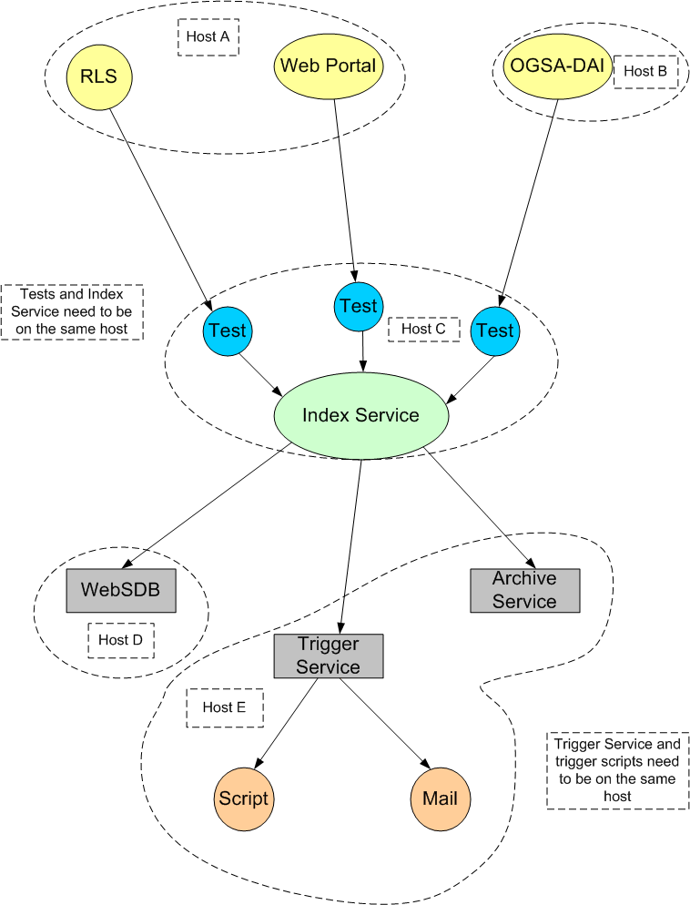

The MDS3 registry obtains and caches information about other services, and allows clients to query and/or subscribe to that data. The registry collects service data from various resources, which it publishes as one big piece of service data. Other services can query for service data elements or subscribe to be notified when they change.

The ESG monitoring system uses the registry to collect and publish information about the current status of ESG services.
ITF: Most people would call “index service” a “registry”.
The ESG monitoring system uses test scripts to verify the correct operation of the various ESG components. These are shell scripts that run periodically on the same machine as the registry, wrap the results of these tests in XML, and then publish the resulting XML in the registry as service data.
ITF: I don’t understand how these work. The figure shows arrows from the services to the tests: does this mean that there is some sort of subscription going on? What are the tests doing? How do you configure the tests? More details would be good.
The new MDS3 archiver is designed to store and allow time-based queries on regitry data. The ESG monitoring system uses the archiver to enable historical queries about component behavior.
ITF: “Web service data browser” sounds like a “data browser” for “Web services.”
The MDS3 service data browser (SDB) is a
customizable display client for service data exposed by grid services.
In the ESG monitoring system, the SDB is used to allow users to query both the registry and the archiver (see below) to determine the current and past status, respectively, of ESG components.

ITF: In the following, I don’t understand how the notification happens, presumably this is part of the configuration too?

The MDS3 trigger provides functionality such as an email gateway to notify system administrators when services fail.
It is configured with a set of Xpath conditions and, for each condition, an action to be performed when the condition is satisfied plus an optional XSLT stylesheet.
The trigger first subscribes to the registry and then, each time a notification is received, then
checks each Xpath condition against the service data in the notification.
If any condition is met, the trigger runs a specified trigger script, with the product of the XSLT transformation applied to the matching XML.

A trigger script may be a simple shell script or a wrapper around other applications such as a grid service clients or mail clients.

Implementation Details
The following is a high-level overview of how CGT set up the ESG framework to monitor a new service:
- Set up an Registry and configure it to publish data from these tests.
http://www-unix.globus.org/toolkit/docs/3.2/installation/install_config_index.html
- Set up hierarchy (index services aggregating other index services)
- Set up Archiver and subscribe to the correct Registry.
[link to future directions]
- Configure the Trigger with conditions and action scripts for this service.
- Write Visualizers (ESG, Archive, Details, explained below), using XSL stylesheets for formatting and displaying the data.
- Set up SDB and install Visualizers.
http://www-unix.globus.org/toolkit/docs/3.2/infosvcs/ws/developer/sbrowser.html

Required Software
- Globus Toolkit 3.2
http://www-unix.globus.org/toolkit/downloads/
- the Archiver package
(coming soon)
- The Trigger package
(coming soon)
- the Service Data Browser
(in the GTR)

ESG Implementation
The following details are specific to deploying the monitoring framework for ESG:
- All components are installed on dc-user.isi.edu (CGT machines) using a single index service.
- Status of services is available on this web page:
http://snipurl.com/StatusPage [shishir needs to provide nicer URL]
- The Trigger sends an email when a broken service is detected.
- The following data is captured:
  - Status (whether the server is up or down)
  - Percentage of uptime
  - Time when the service was last seen alive
  - Time when the service failed

Intended Future Implementation
- Displaying archived data in more interesting and meaningful ways
- Deploying on an ESG node

The following graphic illustrates in more detail how the ESG framework was implemented:
ITF: I’d suggest that you could just have one figure, and include it above where I moved the other one?
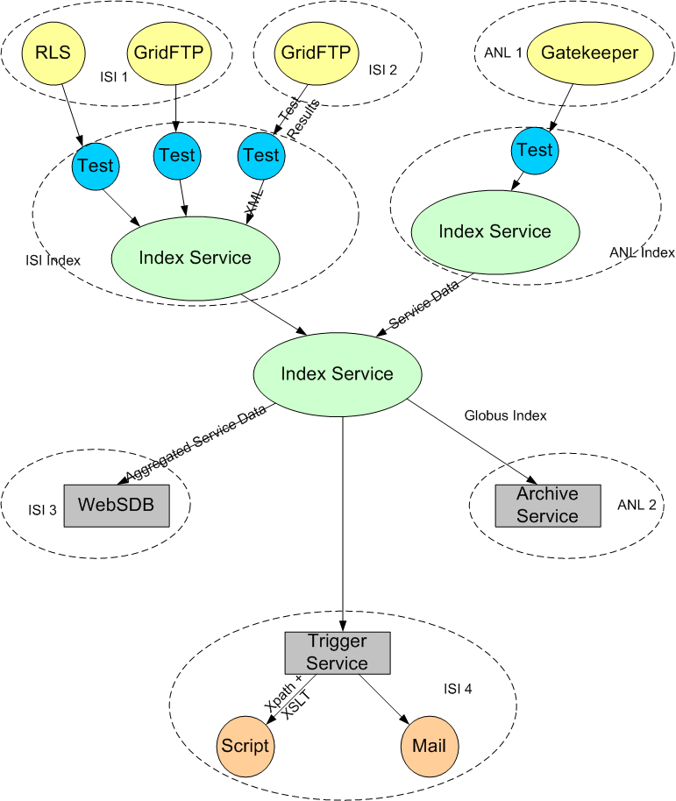

Postconditions
I think this information should occur earlier??
As a result of this deployment, ESG now has the following:
- A scalable system that can easily cope with services being added and removed.
- Better integration with the rest of the Globus Toolkit. ITF: What does this mean?
- Status available for other services to query via the Index Service
- Test results returned as XML:
  - In our current test schema, we allow for a binary UP|DOWN status value, and also a free form comment
  - the free form comment can contain, for example, RLS stats which include number of mappings in the LRC/RLI, uptime, etc.
  - Complex XPath queries can be run against these results as part of the triggering mechanism
- Web-based visualizers that display the status of its chosen services (see the following topics.)

ESG Visualizer
This is the ‘entry page’ for checking out how the various services are doing: status (whether the service is UP or DOWN) and links to more information from the Archiver and Details visualizers. View the ESG Visualizer here.
Screenshot of the ESG Visualizer:
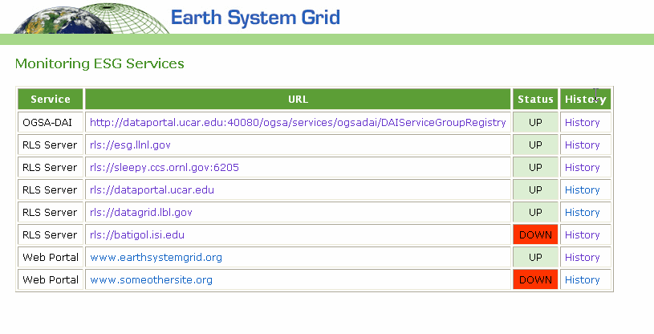

Details Visualizer
From the ESG Visualizer, the Service URL link takes you to the Details Visualizer.
Example of the Details Visualizer:

rls://esg.llnl.gov
Version: 2.0.9
Uptime: 1588:38:54
LRC stats
update method: lfnlist
update method: bloomfilter
updates bloomfilter: rls://datagrid.lbl.gov:39281 last 05/13/04 15:23:59
lfnlist update interval: 86400
bloomfilter update interval: 900
numlfn: 549
numpfn: 551
nummap: 551
RLI stats
updated by: rls://esg.llnl.gov:39281 last 05/13/04 13:39:00
updated by: rls://datagrid.lbl.gov:39281 last 05/13/04 13:40:11
updated by: rls://sleepy.ccs.ornl.gov:6205 last 05/13/04 15:25:50
updated by: rls://dataportal.ucar.edu:39281 last 05/13/04 14:18:43
updated via bloomfilters

Archiver Visualizer
From the ESG Visualizer, the History link takes you to the Archive Visualizer, which displays the historical data ESG specified (percentage of uptime, the timestamp of the reading, status of the server, reporter (test script) and URL.)
Screenshot of the Archive Visualizer:
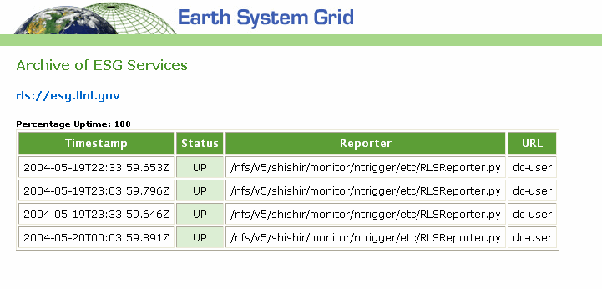

Resources
This page provides information about where and how you can access the tools used in this implementation:
Registry | The Registry is currently available as part of GT3.2:  http://www-unix.globus.org/toolkit/downloads/3.2/index.html  Install the All Services or WS Base Installer package.
Service Data Browser | Developed by Arslan Javed ajaved@isi.edu  Available from the Grid Technology Repository: http://gtr.globus.org/article.php?story=20030723143444410
Archiver | Developed by June Sup Lee (june@isi.edu)  Currently only available through the Globus CVS.
Trigger | Developed by Shishir Bharathi (shishir@isi.edu)  Currently available [where?]

